Photo/Video Upload
Want to double or triple your sales? Let your customers see YOU!


Girls and parents can go to the Site Setup tab in their navigation bar.




From there, scroll down to Step 2: “Write my Cookie Story.” The bottom half of that section “Make your cookie story even better!” is where girls can show their “cookie colors” to their customers.

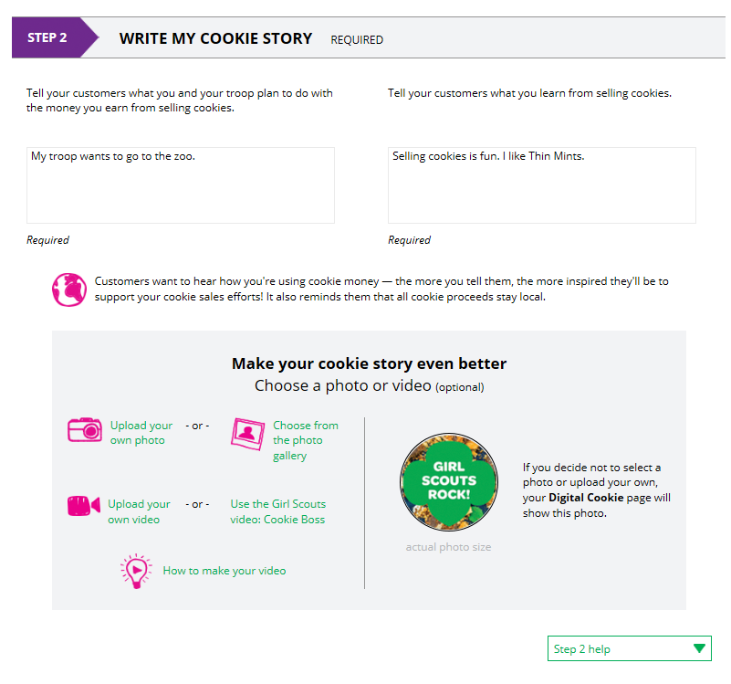
On average, girls who uploaded a photo sold almost twice as many cookies and girls who uploaded a video three times as many boxes as girls who didn’t upload anything!


Girls can choose to use a photo from the gallery already in the DOC by clicking on “Choose from the photo gallery.”


Clicking on that gives them a wide array of choices.
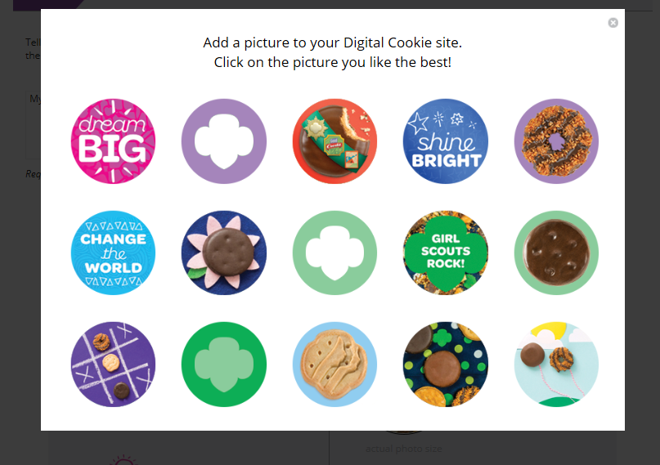

Or they can click “Upload your own photo” and search their own computer files for the photo they want to upload..
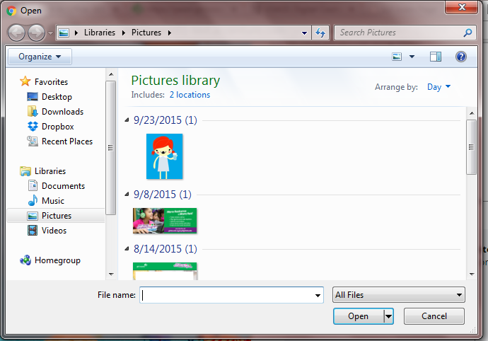

The photo will appear in the preview pane. You can choose to either “Save” and use it on your site, or “Delete” and start over with a new upload.
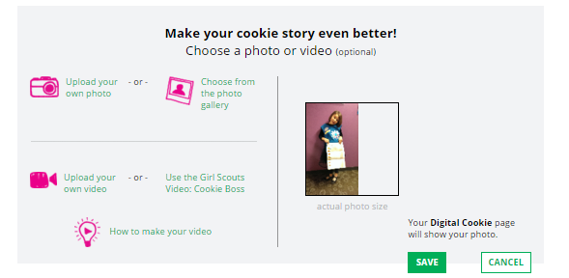
Photo preview

To upload video


Girls can use the Cookie Boss video already in the DOC.

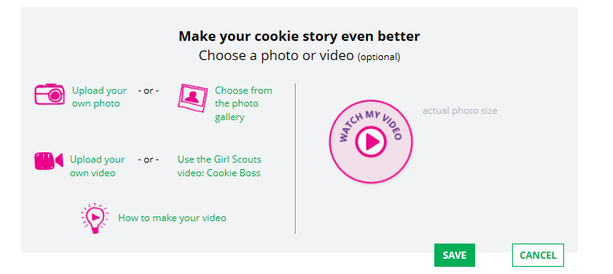

or they can upload their own videos by clicking the “Upload your own video” link.



Clicking the link will take them to their computer files to browse for the video they want to upload.
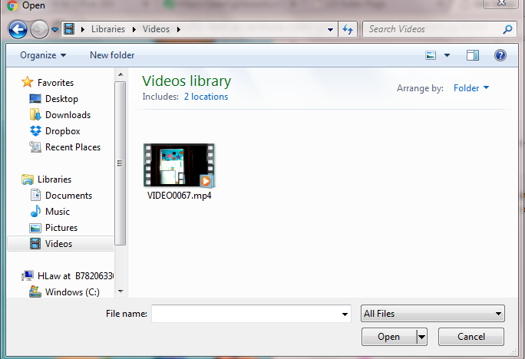

A cute cookie spinner will appear while the video uploads

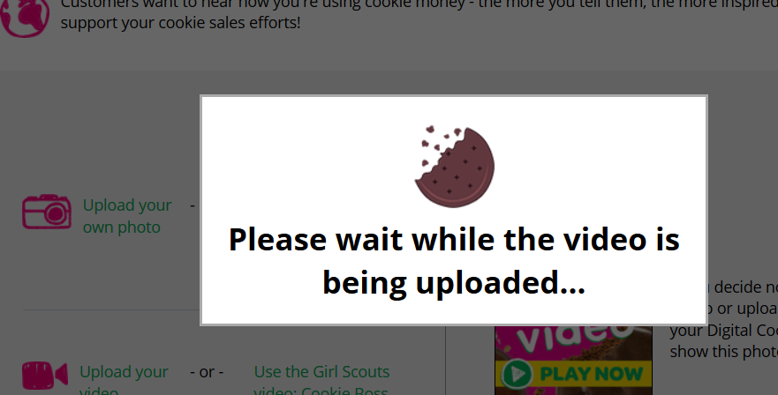

When it uploads, they will see a “Watch My Video” icon. Users can also click the graphic to see a preview of the video in a pop-up video window.
When girls are satisfied with the video, they can click “Save.” If they don’t like it, they can click “Delete” which will remove it from Vimeo; they will need to re-upload using the “Upload your own video” link again.

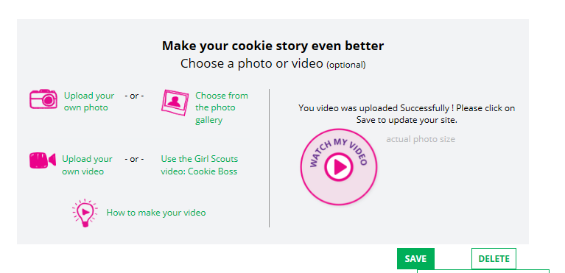
Click to see preview of the video.
Check out the “How to make your video” link for tips about creating a video that everyone will love to watch!

Once a girl has saved her video, she can click the green “Download” button to see it in a full page format.
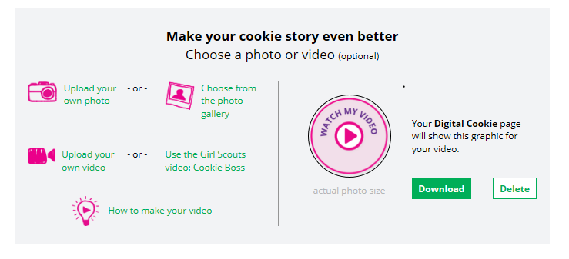

When a girl under age 13 is satisfied with her photo or video, parents will click “See your site and publish.”
When a girl age 13 or over is satisfied with her photo or video, she can click the “See your cookie page and submit for approval” button.



If girls want to see the video again, they can click on it in their site preview.

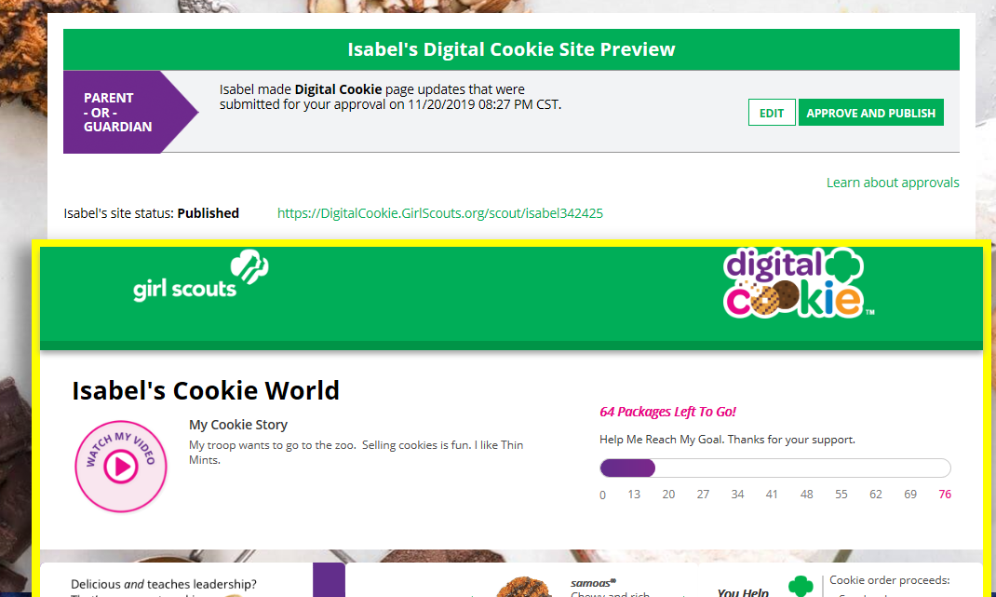

Notes about the Video Upload process:

- If the video hasn’t completed processing, the following screen will show, consistent with Vimeo.com processes. The video usually shows up in a few minutes, depending on the size of the video uploaded. If it doesn’t, you may have to try the upload again. Internet speed and connectivity can be factors in the video processing.

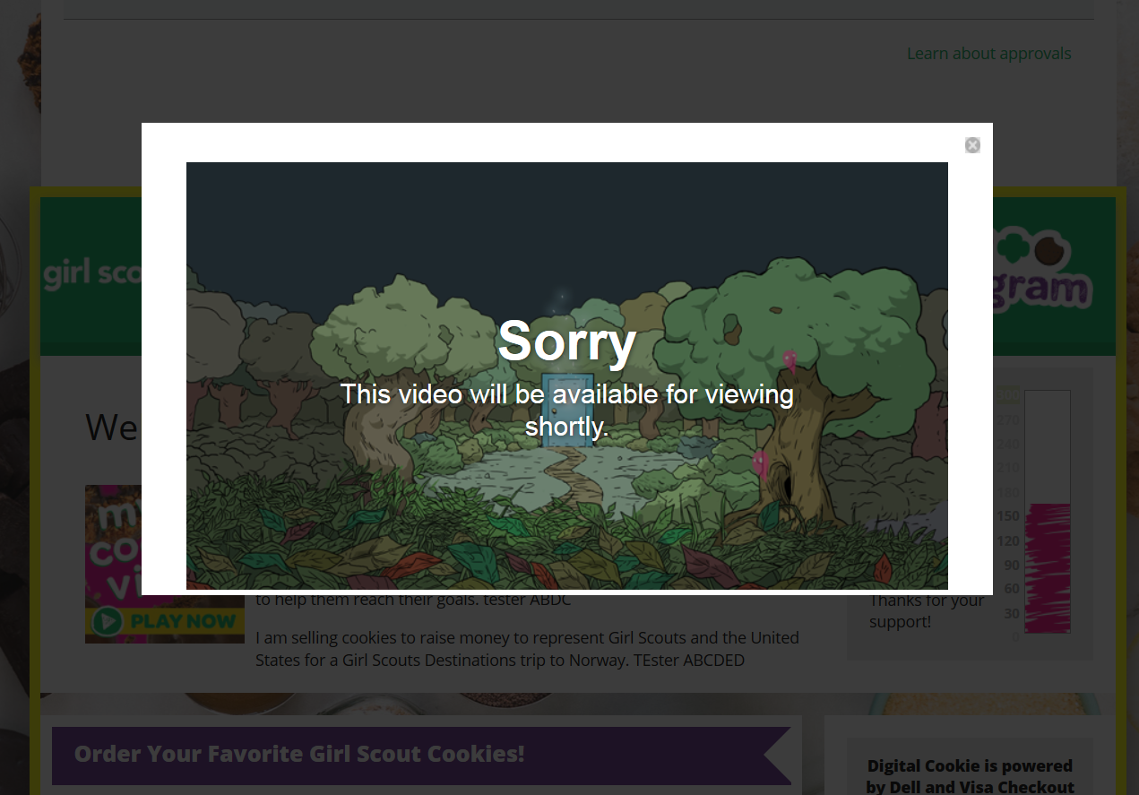

Video that has been uploaded to the GSUSA Vimeo account would look like this. Note the “Private” tag which means users can’t search for these videos on Vimeo.com.

